|  |
| --- |
| Master’s thesis contract  2008 - 2009 |
| **WSN localization with Senseless**  **080515HApaardemarkt029Peter De Cauwer**  **Tim Van Overtveldt** |

ARTE_be_titelblad_cursus_beeld_RGB



# Master’s thesis description

Researchgroup: AMBIT

Masterthesis title: WSN localization with Senseless

Promotor: Jeroen Doggen, Maarten Weyn and Jerry Bracke

Students: Tim Van Overtveldt and Peter De Cauwer

## Goal of this master’s thesis

The goal of this thesis is to use a Wireless Sensor Network (WSN) to locate a note with limited mobility. This system will be interfaced to Scala, another master’s thesis. Scala is an application which combines information from several localization platforms such as GPS and Ekahau. Our thesis will evaluate existing WSN localization algorithms and try to implement the best of them. We will also evaluate the effects of a note’s orientation and its according RSS. The algorithms will be developed in incremental steps, starting with the most simple algorithm. The goal of the algorithms will not solely be the accuracy. Other factors, mostly specific to WSN, will be accounted for as well. Our work should result in a fully functional localization system with a working interface to Scala.

The thesis can be divided into five phases.

* Research: this phase will mainly happen in the first semester. It includes research about existing localization algorithms, RSS models, TOA, AOA etc.
* The Senseless framework: this phase will build on the software project developed in the thematic week of the ICT 7 course. We will adapt this system to support localization data.
* Algorithms: this phase will determine the position of a blind node with several algorithms. To be more concrete: the algorithms researched in the first phase will be implemented in the system which we expanded in the second phase.
* Testing: this phase will determine the accuracy of the the algorithms and the influence of the orientation of a node.
* Interfacing with Scala: building the software interface with the Scala middleware.

Throughout the thesis we will work on the paper. Doing so, we can deliver a better paper.

# Contacts

## Internal promotor

Jeroen Doggen:

+32 498 740546

[Jeroen.doggen@artesis.be](mailto:Jeroen.doggen@artesis.be)

Maarten Weyn:

+32 496 503167

[maarten.weyn@artesis.be](mailto:maarten.weyn@artesis.be)

Jerry Bracke:

+32 472 978897

[Jerry.bracke@artesis.be](mailto:Jerry.bracke@artesis.be)

## Students

Tim Van Overtveldt

+32 493 564013

Tim.vanovertveldt@student.artesis.be

[Tim\_van\_overtveldt@hotmail.com](mailto:Tim_van_overtveldt@hotmail.com)

Peter De Cauwer

+32 498 543441

Peter.decauwer@student.artesis.be

[peterdecauwer@gmail.com](mailto:peterdecauwer@gmail.com)

# Tasks, planning and timepath

## Tasks

1. Research: RSS-based algorithms in a major scientific databases but also via Google Scholar.
2. Survey-paper & Paper
3. Reviewing the possibilty of TOA on TelosB
4. Reviewing RSS propagation theory
5. Senseless framework:
   1. Comparing both frameworks from the thematic ICT week
   2. Reviewing most of the source of the chosen framework
   3. Adapting the framework for localization:
      1. adding new data fields:
         1. Telosb XML parser
         2. Controller
         3. Database design
         4. GUI
         5. Interaface definitions
      2. Algorithms
      3. Calibration
   4. Building a WSN control/status tool
   5. New TelosB application supporting
      1. Localization
      2. Control via the TinyOS dissemination protocol
      3. Multihop
6. SCALA interface
   1. Location data
   2. Sensor data
   3. Map data
7. Testing the influence of mote orientation
   1. Equip the motes with external antennas

## Timepath

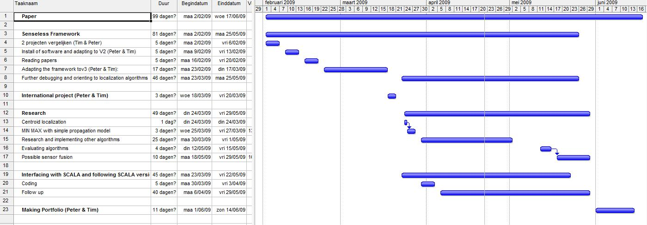

# 

Promotor Promotor Promotor

……………………… ……………………… …………………..

Jeroen Doggen Maarten Weyn Jerry Bracke

Student Student

………………………….. …………………

Tim Van Overtveldt Peter De Cauwer